LABORATORY 3

-

OPERATING SYSTEMS

RUFINO GARCIA SANCHEZ

### **Task 1. System calls and library functions  - comparison of efficiency of system calls and library functions**

**Aim: Develop a program which compares efficiency of system calls and library functions for handling I/O operations.**

**•Description: Write two programs:**

* **Task1a which creates a file with the size given as and argument**

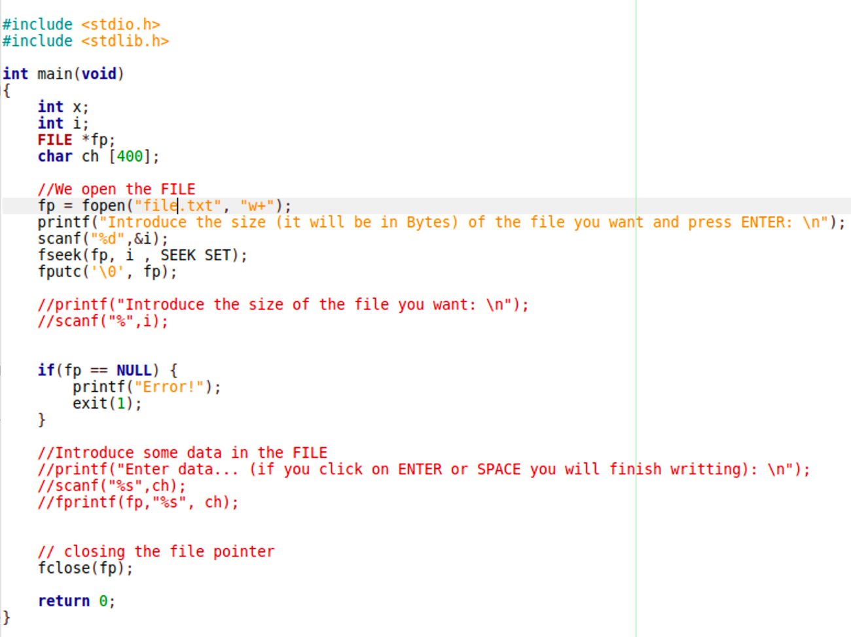



This is my task1a.c. In this program we can observe how we put the size we want.

* **Task1b which copies this file a number of times specified by one of the arguments. This program should be written in two versions:**
  + **(i) using read and write system calls**
  + 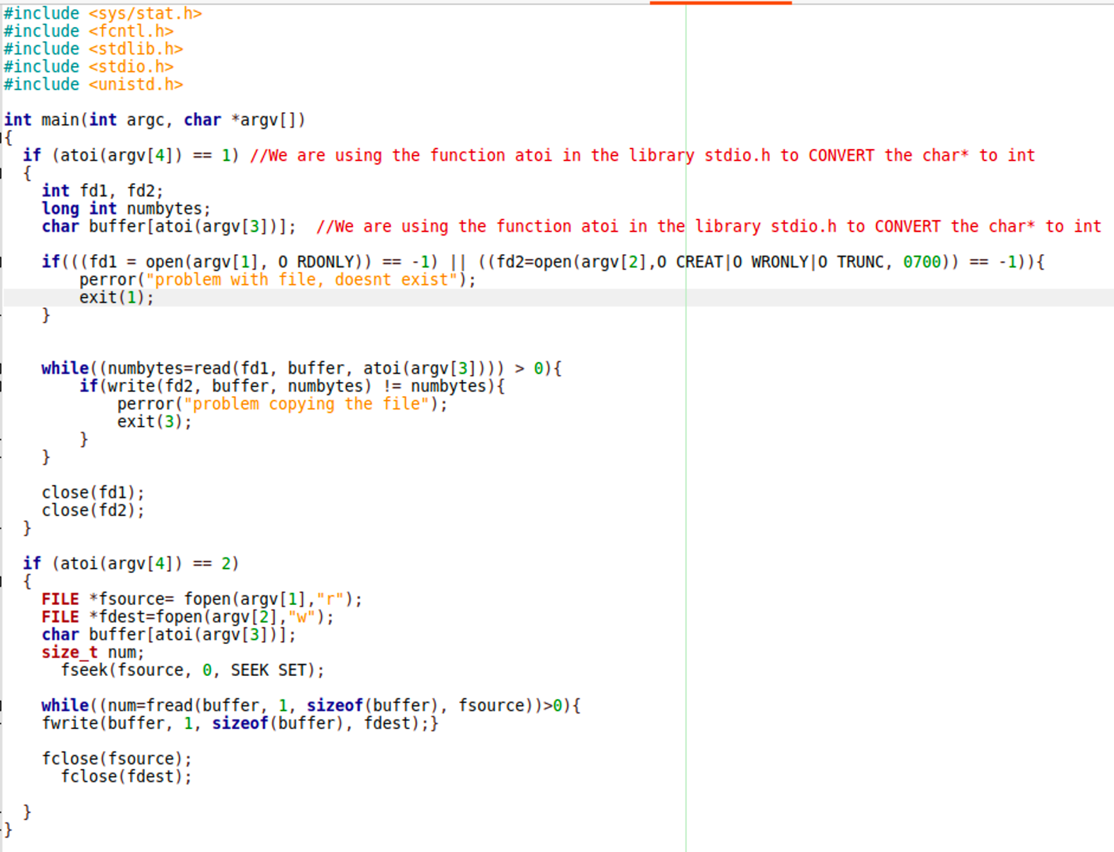**(ii) using fread and fwrite library functions**

As we can observe in this case it depends of what the user will put un the terminal to execute the program.

•For both modes measure real, user and system times for following size of buffers: 1,4,64,256,512,1024,4096,8192 bytes.

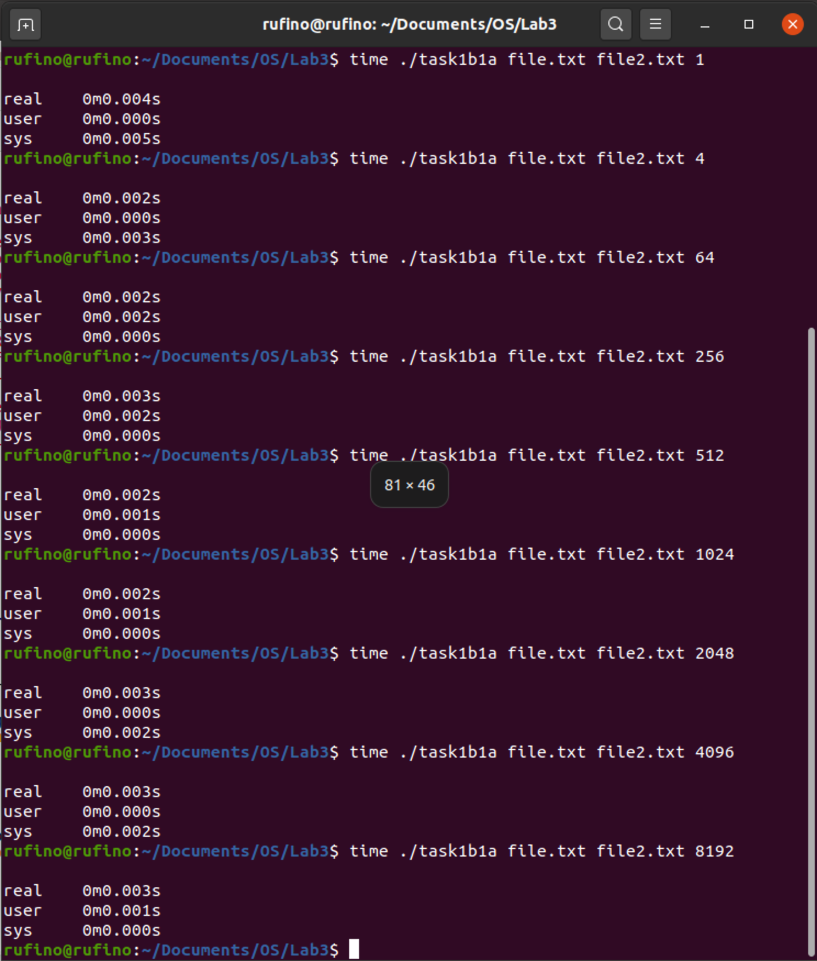

This is with the times with a size of 2048 bites and using write and read systems calls.

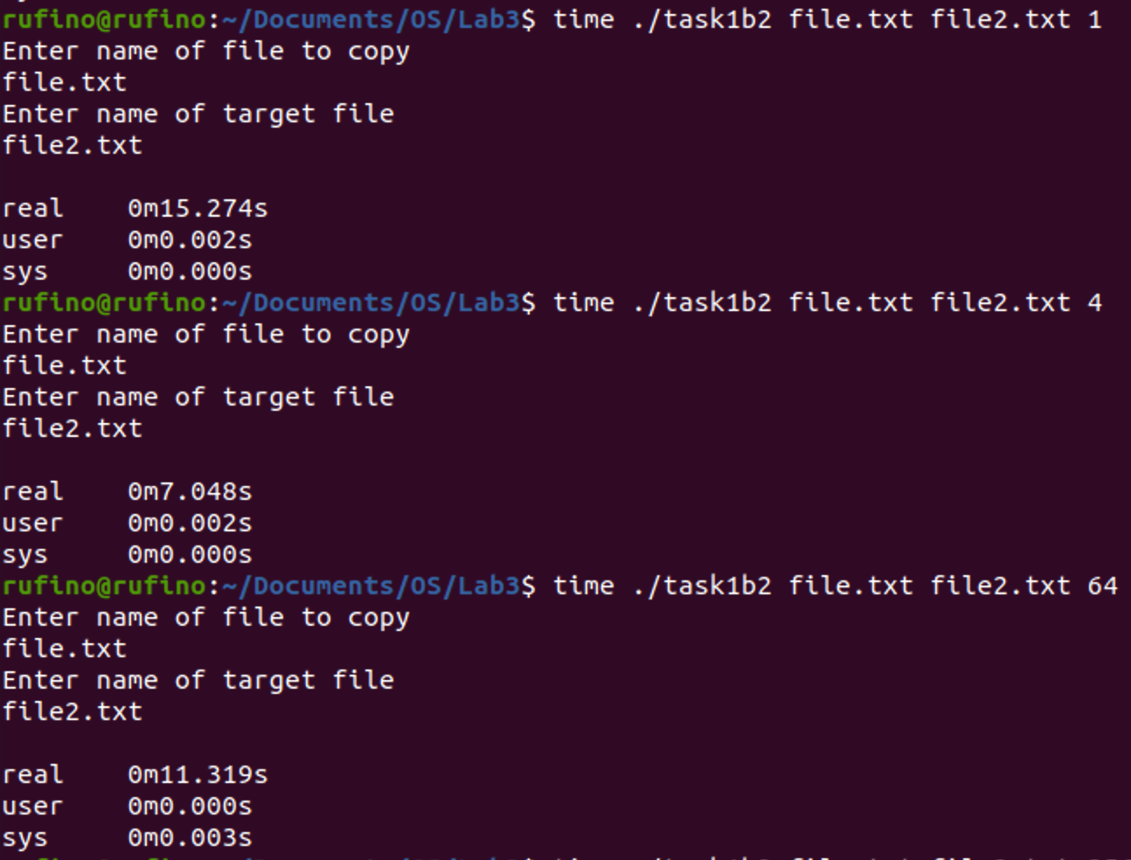

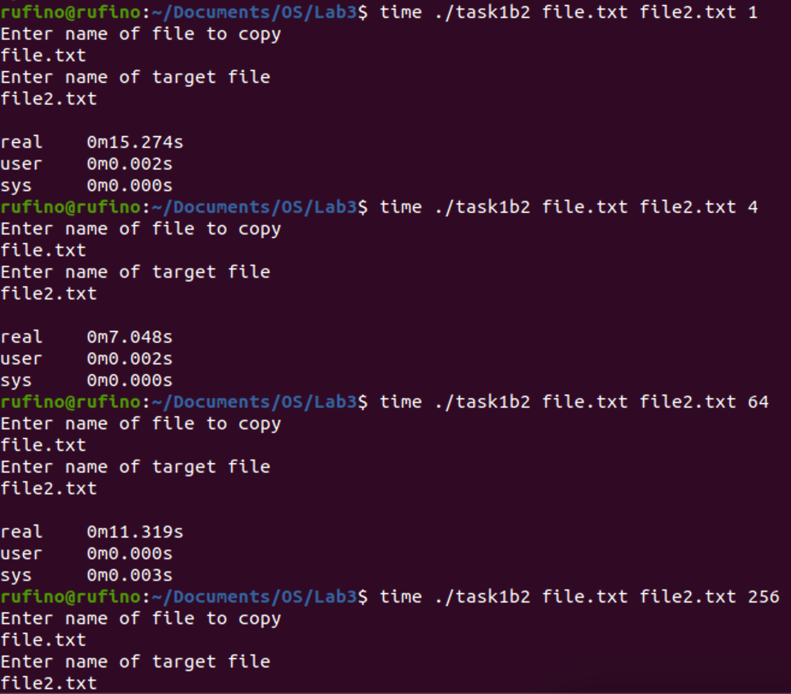









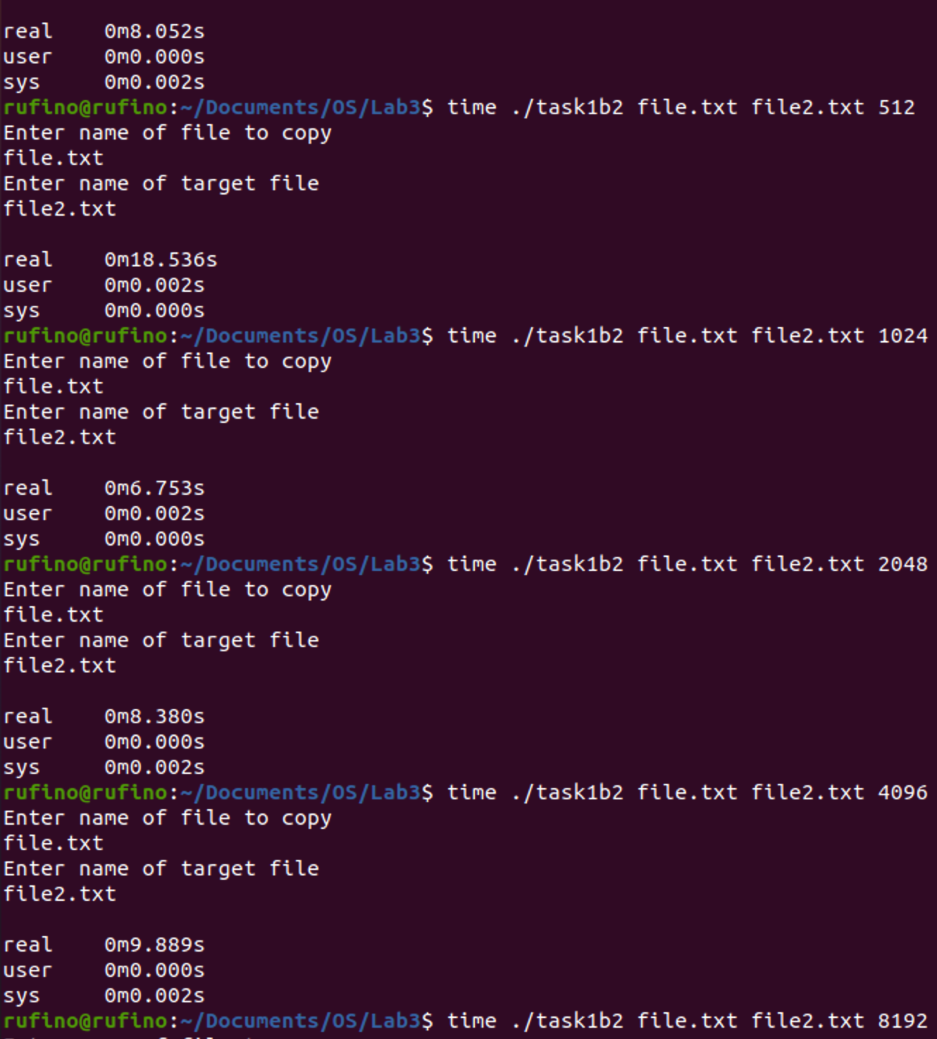****

**

**

**

### 

**

**

**

### 

**We can observe that when the file is bigger the real time is less.**

**All of this is with a file size of 2048 bites.**

### **Task2. Browsing of directories**

Write a program which browses a specified directory (given as the first argument of the program) and displays all names of files in this directory, their sizes and times of the last access and in nested directories.  Only information about normal files should be displayed, links and special files should be omitted. Program should be written in two versions:

* **using opendir, readdir and stat function**

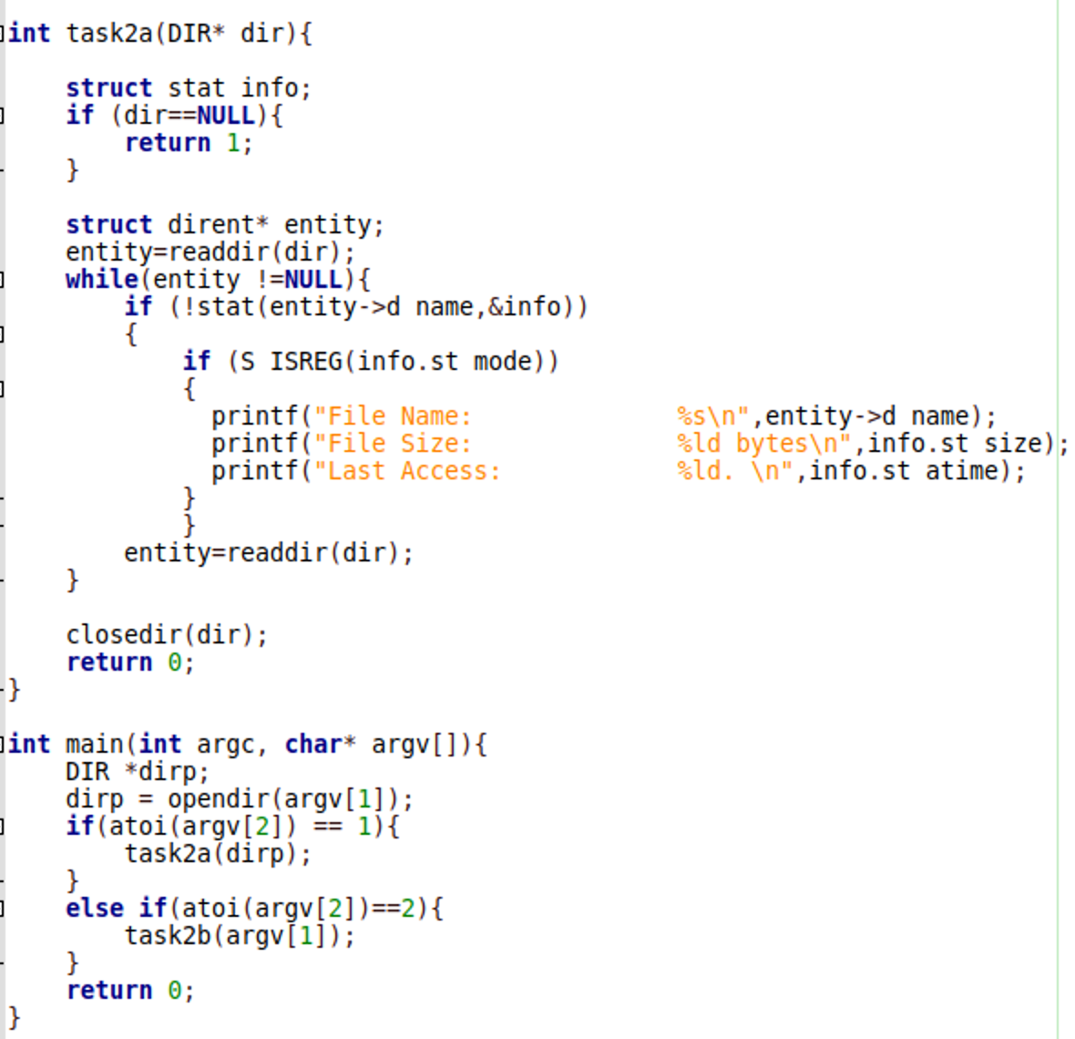

This is my fuction to search the directories using opendir, readdir and stat function.

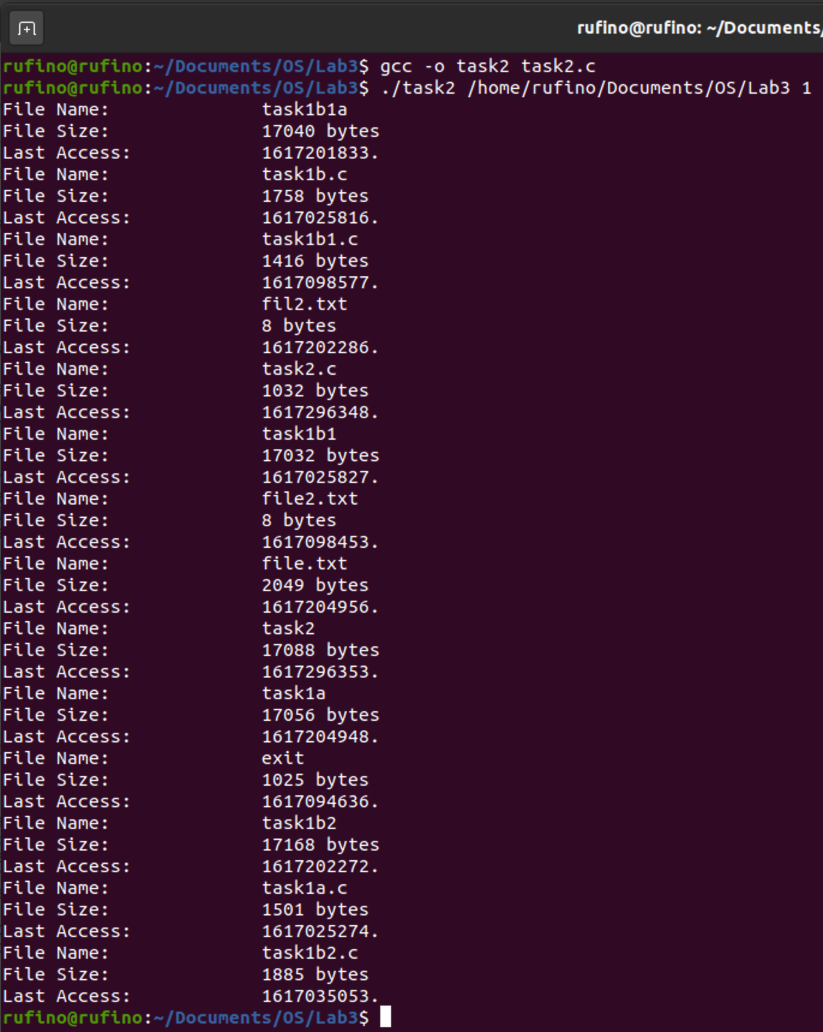

As we can see works correctly.

* **using nftw function**

This version should be chosen according to the second argument.

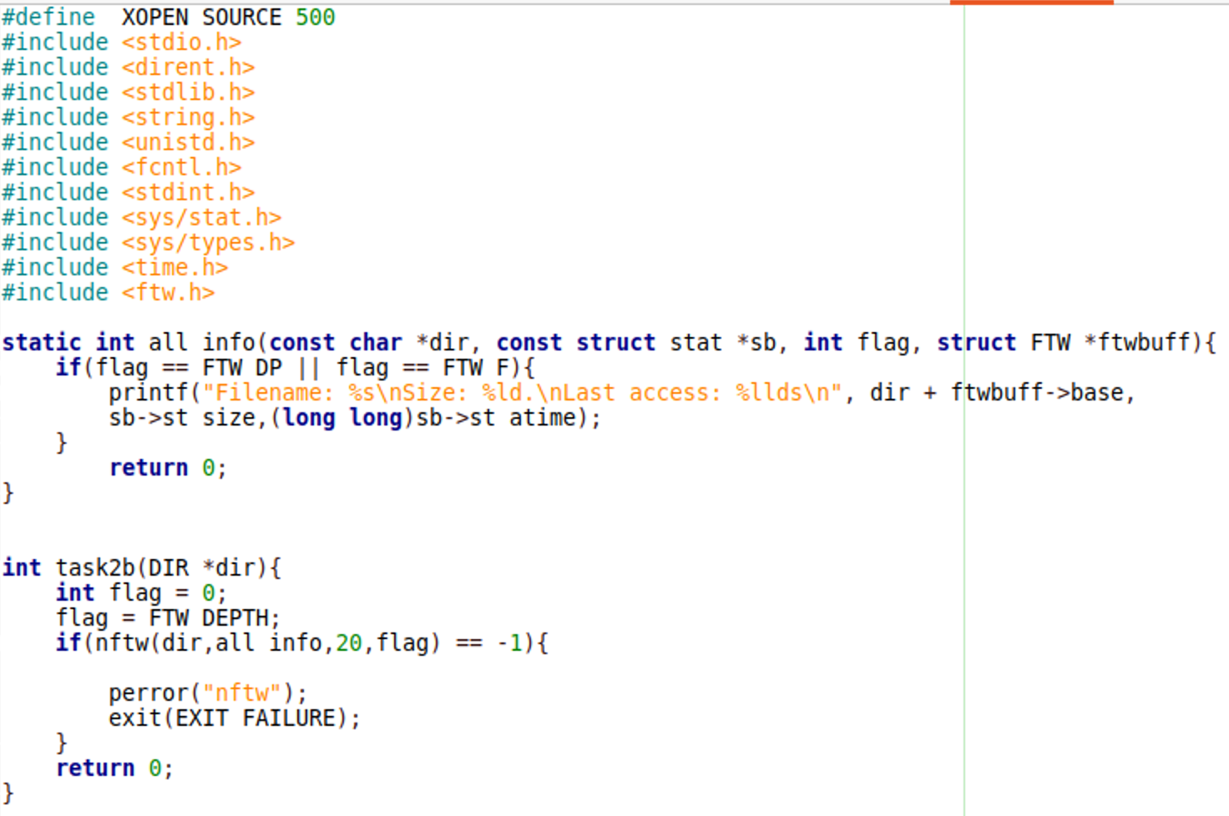

As we can observe this is the code using nftw() function.

To work this part, I have to introcue **#define XOPEN_SOURCE_500**

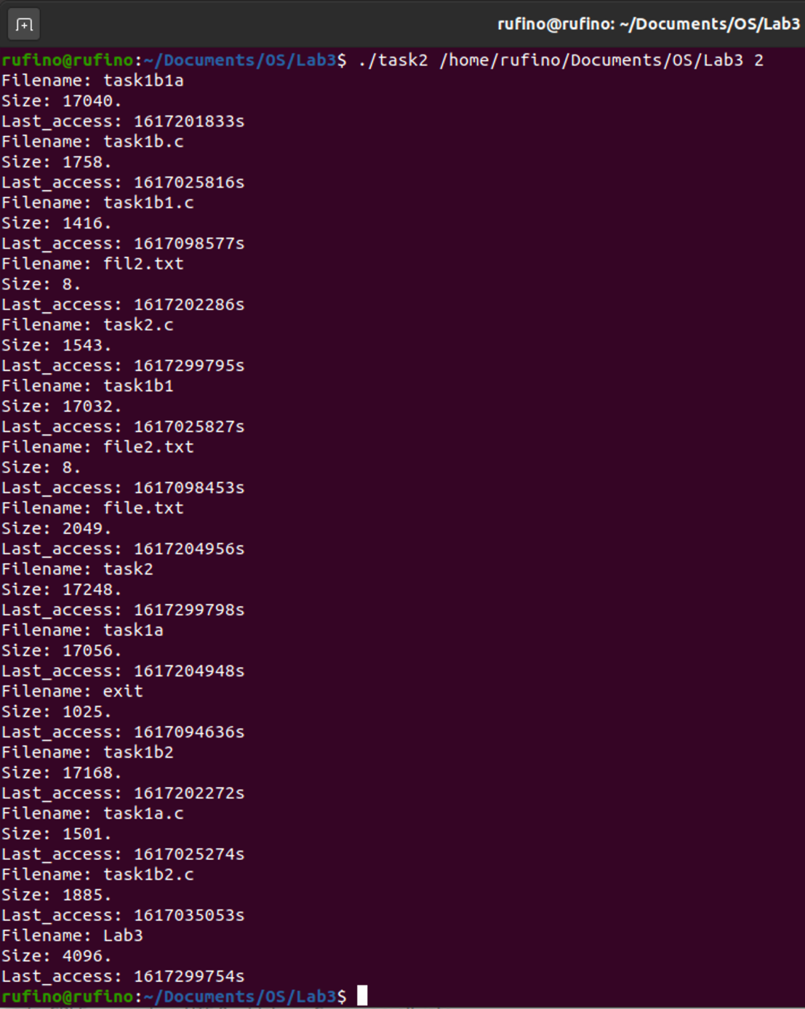

Here we can obsere how the program is executed and how the files are displayed in the terminal like a tree.